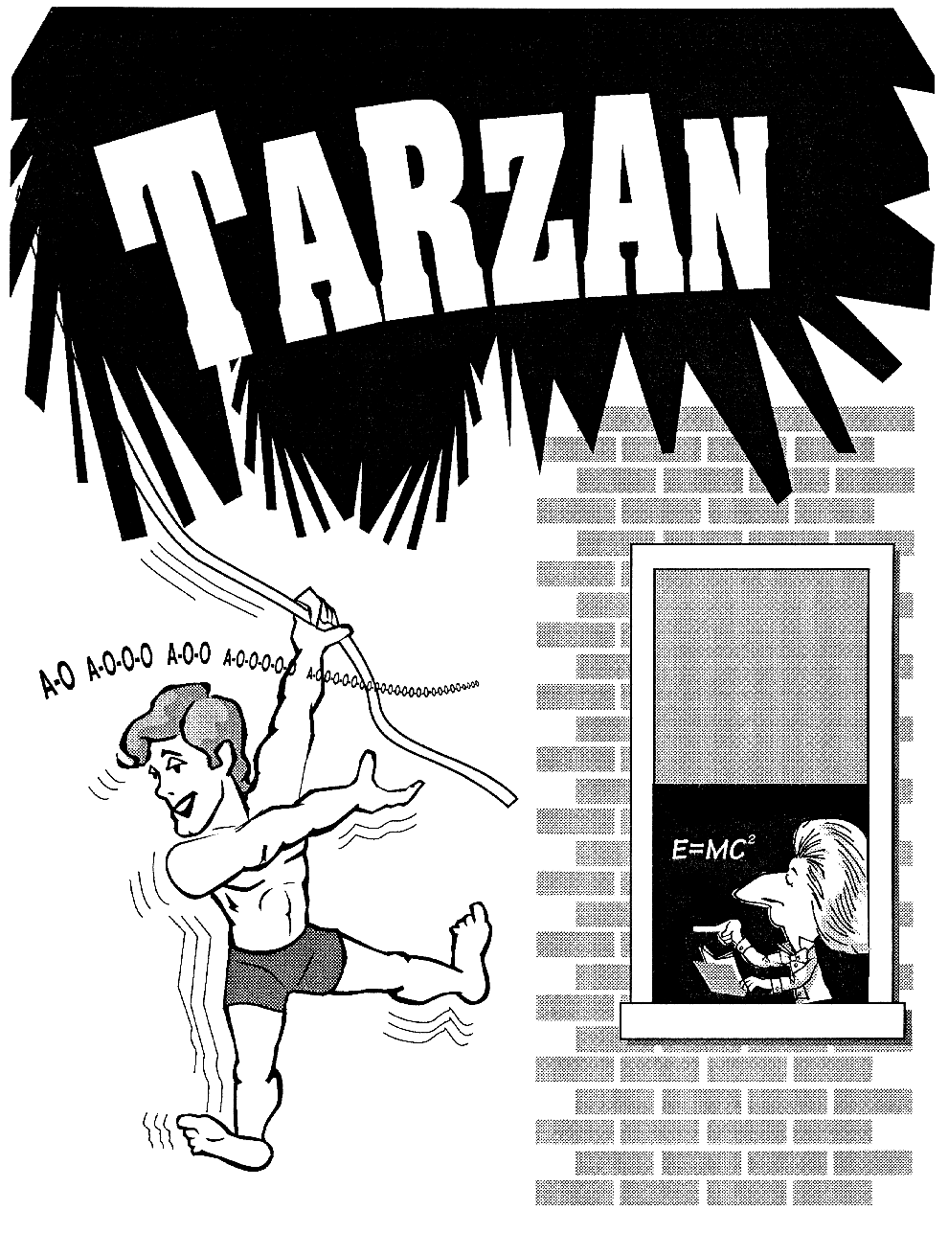
Imagine!!

You’re running as fast as you can through the jungle with fifty head hunters chasing you. Your breath is short and your mouth is dry, but there’s no stopping. For if you stop, you die. Suddenly there’s a cliff. Beside you - a vine. Across the chasm – a cave. Do you swing across? Of course you do; you’re “Tarzan, King (or Queen) of the Jungle”. But consider:

- What if sharp rocks surround the cave? How will you avoid them?

- What if obstacles (huge rocks) are sticking up from the bottom of the chasm? How will you avoid them?

- What if you must let go of your vine part way across the chasm? Can you still safely make it to the cave?

These are just a few of the situations that could develop if you were “Tarzan, King (or Queen) of the Jungle”.
It is now your job NOT to be “Tarzan, King (or Queen) of the Jungle”, but to be “Tarzan, King (or Queen) of the Classroom”. There are nine different levels which you will attempt to conquer. The higher the level, the more advanced the calculations. It will be your job to get Tarzan across the chasm free of injury (in this case get the water balloon through the square hole in the plywood without breaking the balloon).
You will be given certain variables and will be expected to calculate others. You will then swing the water balloon using your findings. If you are correct, Tarzan will go into the cave without harm. But if you are wrong, get ready for the water to fly.

GOOD LUCK!

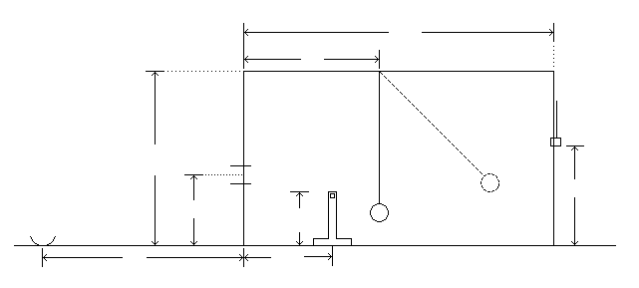
D
L
V
F
W_{y}
W_{x}
R
A_{x}
A_{y}
SUMMARY OF LEVELS

B
H
C

Level | Given | Find | Comments
1 | C,D,L.F | V,H | This level can be solved simply using the Pythagorean Theorem.
2 | C,D,F | L,V,H | This level has many possible solutions. Students learn that there is often more than one solution to a problem.
3 | C,D,F,  obstacle A | L,V,H | This level is complicated by obstacle A in Tarzan’s flight path. Not every solution will work here - only specific paths that avoid the obstacle. Students learn about optimization.
4 | C,D,F,  barrier B  inside the cave | L,V,H | Only solutions that allow Tarzan to enter the cave at slow enough speeds will work. Students learn Conservation of Energy.
5 | C,D,F, hot  wire position | L,V,H | Students determine solution such that string is cut at correct instant and Tarzan is projected safely into the cave. Students learn projectile motion. Also, starting with this level, students must consider string tensile strength/centripetal force.
6 | C,D,F, and  hot wire position | L,V,H  net location R | This level is the same as level five, except that Tarzan’s landing point must now be determined.
7 | C,D,F, net  location R | L,V,H, hot  wire position | Similar to level 6, but students are given a landing position and then must determine the hot wire position.
8 | C,D,F,V  spring force vs.  stretch relationship and mass of Tarzan and spring | L,H  tension in vine | This level introduces spring constants and acceleration. With a stiff spring in the vine, Tarzan is pulled back to a calculated tension and is launched into the cave.
9 | C,D,F,  spring force vs.  stretch relationship and mass of Tarzan and spring | L,V,H | This level is most difficult and is best solved by writing a computer program to do numerical integration. A soft spring produces slow acceleration, and then deceleration before the cave is reached.

Tarzan Lab Report Format

Each level of the Tarzan Swing Lab Report should have the following sections in this order:

- Objective of the Level – The handout provided (or a similar substitute) is sufficient.

- Given Information and Diagram – The handout provided (or a similar substitute) is sufficient.

- Detailed Calculation of Correct Solution – This section should be neatly handwritten or typed. It should be well organized and include commentary explaining your calculations. This should be your corrected solution if you have one, not one that failed when tested.

- Graphs/Charts of Solution – Draw a complete graph showing Tarzan’s path through the cave opening. Use the “scaled” graph paper provided (or a similar substitute), or your own diagram neatly done on a computer.

- Explanation and Analysis of Failures – If you had any failures while testing your solutions in the lab (i.e. if you had to wipe up water), this is the section to describe the failure and give your best explanation (analysis) as to why it failed.

- Summary/Conclusion – This should NOT be a restatement of the objective. Use this section to “show off” what you have learned from completing this level.

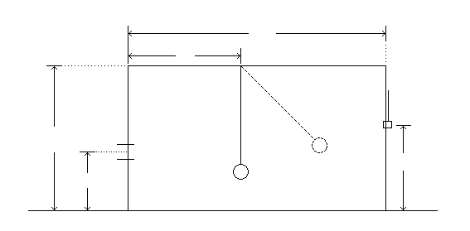
F
C
L
D
H
V

LEVEL 1
Student Objective:
To determine Tarzan’s vine length (V) and the release height of Tarzan (H) such that Tarzan reaches the cave safely.

Given:
Floor to pivot point (F) = 66.75 inches
Release plane to cave plane (D) = 85.75 inches
Maximum vine length = 65 inches
Balloon mass = 100 grams
Balloon diameter 2.5 inches

Cave height (C) = ___________ inches
Cave plane to pivot point (L) = ____________ inches

Instructions:
Show your calculations for the vine length (V) and release height (H). Attach extra paper if necessary. Sketch (using a compass and ruler) the path of Tarzan using your solution on the given graph paper.

Vertical Height Above Chasm Floor (inches)
Horizontal Distance From Cave Plane (inches)
60
50
40
30
20
10
0
0
10
20
30
40
50
60
70
80

LEVEL 2
F
C
L
D
H
V
Student Objective:
To determine Tarzan’s vine length (V), release height (H) and the pivot point location (L) such that Tarzan reaches the cave safely. Be aware that there are a range of solutions, but not all solutions will work.

Given:
Floor to pivot point (F) = 66.75 inches
Release plane to cave plane (D) = 85.75 inches
Maximum vine length = 65 inches
Balloon mass = 100 grams
Balloon diameter 2.5 inches

Cave height (C) = ___________inches

Instructions:
Show your calculations for the vine length (V), release height (H), and pivot point location (L). Attach extra paper if necessary. Sketch (using a compass and ruler) the path of Tarzan using your solution on the given graph paper

Vertical Height Above Chasm Floor (inches)
Horizontal Distance From Cave Plane (inches)
60
50
40
30
20
10
0
0
10
20
30
40
50
60
70
80

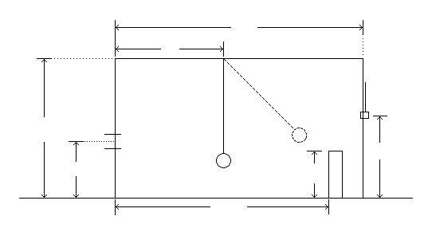
LEVEL 3
F
A_{x}
A_{y}
H
L
D
V
C

Student Objective:
To determine Tarzan’s vine length (V), release height (H) and pivot point locations (L) such that Tarzan clears the obstacle A and reaches the cave safely.

Given:
Floor to pivot point (F) = 66.75 inches
Release plane to cave plane (D) = 85.75 inches
Maximum vine length = 65 inches
Balloon mass = 100 grams
Balloon diameter 2.5 inches

Cave height (C) = ________ inches
Obstacle distance from the cave (A_{x}) = ________inches
Obstacle height from the floor (A_{y}) = _________inches

Instructions:
Show all of your calculations that were necessary to solve this level. Attach extra pages if necessary. Sketch (using compass and ruler) the path of Tarzan using your solutions. Include obstacle A in your sketch.

Vertical Height Above Chasm Floor (inches)
Horizontal Distance From Cave Plane (inches)
60
50
40
30
20
10
0
0
10
20
30
40
50
60
70
80

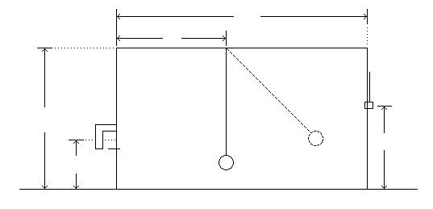
LEVEL 4
D
L
C
F
V
H
B

Student Objective:
To determine Tarzan’s vine length (V), release height (H), and pivot point location (L) such that Tarzan has enough energy to enter the cave without hitting the cave barricade.

Given:
Floor to pivot point (F) = 66.75 inches
Release plane to cave plane (D) = 85.75 inches
Maximum vine length = 65 inches
Balloon mass = 100 grams
Balloon diameter 2.5 inches

Cave height (C) = ________inches
Barricade dimensions:
Height (Y) = _________inches
Depth (X) = _________inches

Be sure to account for an energy loss (friction/air-resistance) of ____% when Tarzan swings across the chasm.

Instructions:
Show all of your calculations that were necessary to solve this problem. Attach extra pages if necessary. Sketch (using a compass and ruler) the path of Tarzan on the provided graph paper. Include the cave barricade B in your sketch.
The Energy Concept and Its Relation to the Tarzan Swing

Starting with level 4 of the Tarzan Swing, it will become extremely important for you to understand the energy conservation concept. So this is a brief introduction to the concept.
Any time an object is in motion, it has KINETIC ENERGY, or energy of motion. Any time an object has energy, this means it is capable of doing work. For example, if I throw an eraser across the room, it could hit someone and wake them up. The eraser has the ability to do work because it is in motion. The amount of kinetic energy that an object has depends on its mass and speed. The relationship is as follows:

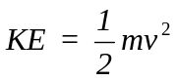

m = mass of the object (kg)
v = speed of the object (m/s)
KE = kinetic energy (Joules)

When an object is at an elevated position, it has the potential to do work. For example, if I have a heavy pot sitting on a shelf in my home, then the pot could fall and smash itself (or something else). We call this type of energy POTENTIAL ENERGY because it is stored energy. The pot has the potential to fall and break itself. The amount of potential energy that an object has depends on its mass and its height. The relationship is as follows:

PE = m g h

m = mass of object (kg)
g = 9.8 m/s²
h = height of object (m)
Energy cannot be made or destroyed - it can only be converted from one form to another. When an object starts at an elevated position, then when it falls (or swings) its potential energy (stored energy) is converted to kinetic energy (energy of motion). So setting KE = PE, we can solve out for the object’s speed after it has fallen a distance h.

KE = PE

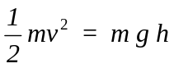

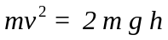

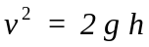

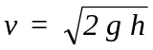

So when the Tarzan water balloon has fallen a total distance h, it will have a speed v as determined by the above equation. So if you can determine the height of your Tarzan balloon when the vine is cut, then you can determine its speed. For example:

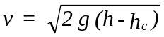

g = 9.8 m/s² = 32 ft/s² = 384 in/s²
h = height of Tarzan balloon when released (m or inches)
h_{c} = height of Tarzan balloon when vine is cut (m or inches)
v = speed of Tarzan balloon when vine is cut (m/s or inches/s)

Vertical Height Above Chasm Floor (inches)
Horizontal Distance From Cave Plane (inches)
60
50
40
30
20
10
0
0
10
20
30
40
50
60
70
80
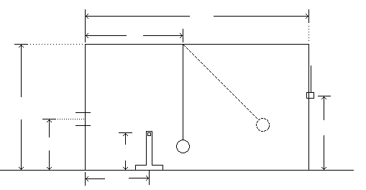

LEVEL 5
F
C
W_{x}
W_{y}
V
D
L
H

Student Objective:
To determine Tarzan’s vine length (V), release height (H), and pivot point location (L), such that the vine is cut, and Tarzan projects through the cave safely.

Given:
Floor to pivot point (F) = 66.75 inches
Release plane to cave plane (D) = 85.75 inches
Maximum vine length = 62 inches
Vine tensile strength = 15.0 Newtons
Balloon mass = 100 grams
Balloon diameter 2.5 inches

Cave height (C) = ________inches
Distance of wire from cave (W_{x}) = ________ inches
Distance of wire off ground (W_{y}) = _________inches

Be sure to consider an energy loss (friction/air-resistance) of ____% when Tarzan swings across the chasm.

Instructions:
Show all of your calculations that were necessary to solve this level, including a calculation using the following coordinate system to show that the maximum vine tension exerted by your solution does not exceed the vine tensile strength. Attach extra pages if necessary. Sketch (accurately - using a compass and ruler) the path of Tarzan such that he is projected safely into the cave. Include the hot wire position in your sketch. Keep in mind that after Tarzan’s vine is cut, he will be following a parabolic trajectory. How will you accurately draw this in your diagram? Explain your method as part of your report.

Sketch a free body diagram for Tarzan when he is at the bottom (lowest part) of his swing. Remember to include the air-resistant force here (assuming Tarzan is moving to the left).

Y (vine direction)

X (axis of motion)

We know that the forces on Tarzan along the radial (vine) direction must sum to the necessary centripetal force.

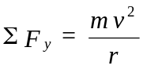

Write the appropriate force equation and solve for tension (T) in the vine.

Vertical Height Above Chasm Floor (inches)
Horizontal Distance From Cave Plane (inches)
60
50
40
30
20
10
0
0
10
20
30
40
50
60
70
80

LEVEL 6
D
L
V
F
C
W_{y}
W_{x}
R
H

Student Objective:
To determine Tarzan’s vine length (V), release height (H), pivot point location (L), and landing spot (R), such that when the vine is cut, Tarzan projects safely through the cave and into a basket.

Given:
Floor to pivot point (F) = 66.75 inches
Release plane to cave plane (D) = 85.75 inches
Maximum vine length = 62 inches
Vine tensile strength = 15.0 Newtons
Balloon mass = 100 grams
Balloon diameter 2.5 inches
Basket height = 4 inches

Cave height (C) = ________ inches
Distance of wire from cave (W_{x}) = ________inches
Distance of wire off ground (W_{y}) = ________inches

Be sure to consider energy loss (friction/air-resistance) of _____% when Tarzan swings across the chasm.

Instructions:
Show all of your calculations that were necessary to solve this level, including a calculation using the following coordinate system to show that the maximum vine tension exerted by your solution does not exceed the vine tensile strength. Attach extra pages if necessary. Sketch (accurately - using a compass and ruler) the path of Tarzan such that he is projected safely into the cave. Include the hot wire position in your sketch. Keep in mind that after Tarzan’s vine is cut, he will be following a parabolic trajectory. How will you accurately draw this in your diagram? Explain your method as part of your report.

Sketch a free body diagram for Tarzan when he is at the bottom (lowest part) of his swing. Remember to include the air-resistant force here (assuming Tarzan is moving to the left).

Y (vine direction)

X (axis of motion)

We know that the forces on Tarzan along the radial (vine) direction must sum to the necessary centripetal force.

Write the appropriate force equation and solve for tension (T) in the vine
Cave Plane
Release Plane
Vertical Height Above Chasm Floor (inches)
0
20
40
60
0
20
40
60
80
-20
-40
-60

Horizontal Distance From Cave Plane (inches)

release plane
C
H
LEVEL 7
D
L
V
F
W_{y}
W_{x}
R
Student Objective:
To determine Tarzan’s vine length (V), release height (H), pivot point location (L), and hot wire position, such that when the vine is cut, Tarzan projects safely through the cave and into the basket.

Given:
Floor to pivot point (F) - 66.75 inches
Release plane to cave plane (D) = 85.75 inches
Maximum vine length = 62 inches
Minimum x coordinate for hot wire (Wx) = 11 inches
Maximum y coordinate for hot wire (Wy) = 40 inches
Minimum y coordinate for hot wire (Wy) = 11 inches
Vine tensile strength = 15.0 Newtons
Balloon mass = 100 grams
Balloon diameter 2.5 inches
Basket height = 4 inches

Cave height (C) = _________ inches
Basket location (R) = ________ inches
Instructions:
Show all of your calculations that were necessary to solve this level, including a calculation using the following coordinate system to show that the maximum vine tension exerted by your solution does not exceed the vine tensile strength. Attach extra pages if necessary. Sketch (accurately - using a compass and ruler) the path of Tarzan such that he is projected safely into the cave. Include the hot wire position in your sketch. Keep in mind that after Tarzan’s vine is cut, he will be following a parabolic trajectory. How will you accurately draw this in your diagram? Explain your method as part of your report.

Sketch a free body diagram for Tarzan when he is at the bottom (lowest part) of his swing. Remember to include the air-resistant force here (assuming Tarzan is moving to the left).

Y (vine direction)

X (axis of motion)

We know that the forces on Tarzan along the radial (vine) direction must sum to the necessary centripetal force.

Write the appropriate force equation and solve for tension (T) in the vine.
Cave Plane
Release Plane
Vertical Height Above Chasm Floor (inches)
0
20
40
60
0
20
40
60
80
-20
-40
-60

Horizontal Distance From Cave Plane (inches)
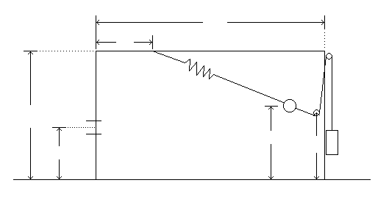
Student Objective:
LEVEL 8
F
C
L
D
V
H
T
X
To determine Tarzan’s release height (H), pivot point location (L), and vine tension (or load T) such that Tarzan is launched by the rubber band and is projected through the cave safely.

Given:
Floor to pivot point (F) = 66.75 inches
Release plane to cave plane (D) = 85.75 inches
Max. load (T) = 2000 grams
Min. load (T) = 1400 grams
Max. pivot (L) = 22 inches
Min. pivot (L) = 5 inches
Max. ball release height (H) = 60 inches
Min. ball release height (H) = 35 inches
Maximum ball horizontal release point (X) = 77 inches
Unstretched vine length (V) = 59 inches
Golf ball (Tarzan) mass = 50 grams
Rubber band mass = 8 grams

Cave height (C) = ________inches

Load (T) in grams vs. stretch (x) in meters for rubber band

T = (SF) (x^{2/3})

The available kinetic energy (KE) in Joules vs. stretch (x) in meters

KE = 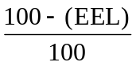(EF)(x^{5/3})

Important Note:
During the launch acceleration period, there will be energy lost as heat due to internal damping in the rubber, the ball and rubberband will likely change their gravitational potential energy some, and the launch angle will change slightly due to gravity pulling down on the ball. However, these, as well as losses from air resistance, have been accounted for in the equation above. The above equation for kinetic energy gives you the total kinetic energy (in Joules) that goes into the golf ball and the rubber band. Assume the rubberband ends up moving at the same speed as the ball.

Instructions:
Show all of your calculations that were necessary to solve this level. Attach extra pages if necessary. Sketch (accurately) the path of Tarzan showing that he is propelled by the rubber band and projected safely into the cave.

Vertical Height Above Chasm Floor (inches)
Horizontal Distance From Cave Plane (inches)
60
50
40
30
20
10
0
0
10
20
30
40
50
60
70
80

